

**Tuesday, April 29, 2014 9:00 AM to 2:30 PM Fern Resort, Orillia**

Key Note Speaker:

**Kelven Tan**

**“Crouching Tiger, Listening Heart, Strategic Marketing through Consumer Insights”**



**SECTOR:** Accommodation Attraction Event Public Service Other

**Registration Form**

**$65.00/per person - tax included - Light breakfast, lunch and refreshments**

Limited Seating Available

***Registration & Cancellation Policy: Due to limited seating registration must be pre-paid. Regrettably, we are unable to offer any refunds; however substitution is welcomed at any time.***



Fax or email completed registration to 705-728-9130

Tourism Simcoe County

Phone: 1-800-487-6642 Email: [diana.coulson@simcoe.ca](mailto:diana.coulson@simcoe.ca)

***Please note all registered participants will receive a confirmation by email***

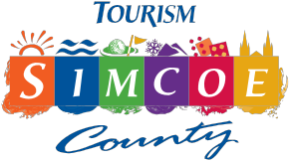

Simcoe County Rural Tourism Conference For more information contact: Tourism Simcoe County [diana.coulson@simcoe.ca](mailto:diana.coulson@simcoe.ca%20)



**experience.simcoe.ca**









[](http://www.tourismbarrie.com/)

Organizing Committee Partners









