Call for Nominations and Applications
Board of Directors

Regional Tourism Organization 7 seeks nominations and applications to fill three vacancies on its Board of Directors:

- One director representing the tourism sector in Bruce County; and
- One director representing the public tourism sector* in Grey County; and
- One director representing the tourism sector at large (from Bruce, Grey or Simcoe)

* The public tourism sector: representing government, government-based and community organizations,
as defined by current or past employment

RTO7’s industry-led, volunteer board is responsible for providing direction to the organization in fulfillment of the organization’s mission, which is “to work collaboratively with tourism partners and stakeholders to enrich BruceGreySimcoe’s diverse tourism experiences and to build, sustain and grow visitation, investment and visitor spending.” For information about:

- Regional Tourism Organization 7: www.rto7.ca
- Ontario’s tourism regions: www.mtc.gov.on.ca/en/regions/regions.shtml

RTO7’s vision is “to establish BruceGreySimcoe as Ontario’s four season destination of choice.” For information about BruceGreySimcoe, visit www.BruceGreySimcoe.com.

Important Information
These are volunteer positions. Directors are expected to have relevant board and/or management experience, leadership, skills and qualifications that would recommend them as directors of a non-profit corporation.

Interested individuals should: review the policy information provided (Section 1); and complete the application form (Section 2); and submit along with a current C.V. (resume). All information is confidential.

The deadline for applications is Nov 18, 2013. Decisions are expected on or before Dec 15, 2013.
All applicants are thanked for their interest and will be contacted.

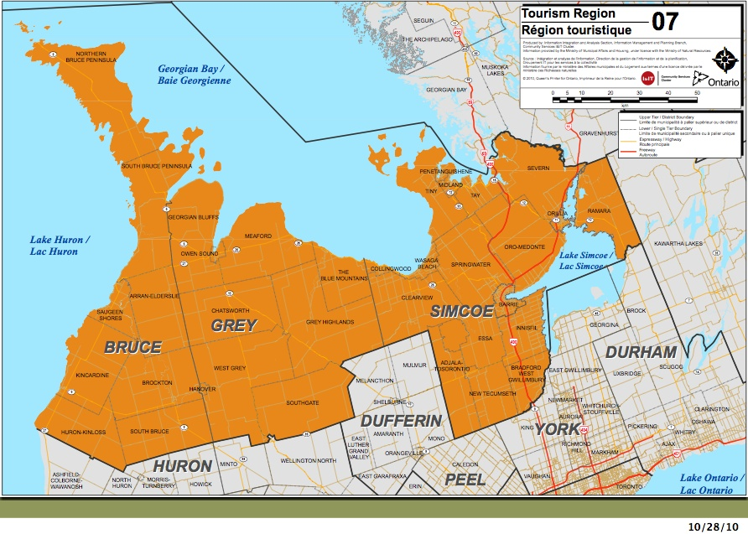
For more information, contact:

Cindy Strong
Administrative Coordinator
(705) 888-8728
cstrong@rto7.ca
1. RTO7 Policies

Board Structure
RTO7’s industry-led, volunteer board consists of 11 to 15 directors. The board is structured to provide for balanced representation from across the region among key tourism sectors, as well as private and non-private industry stakeholders. The board is comprised of:
- Three representatives from each of Bruce, Grey and Simcoe Counties; the balance of directors are designated as at-large directors
- At least eight representatives from private industry tourism sector
- At least three representatives from the public tourism sector (which includes government, government-based and community organizations as defined by current or past employment), with at least one such representative from each of Bruce, Grey and Simcoe Counties

Expectations
- Directors serve in a voluntary capacity and must be prepared to make a commitment of active service involving monthly half to full-day board and committee meetings
- Directors are expected to have relevant board and/or management experience, leadership, skills and qualifications that would recommend them as directors of a non-profit corporation
- The term of office for directors is three years. No director may serve more than two consecutive terms

Responsibilities of Directors
- Support the objectives and interests of RTO7, and conform with its by-laws, values and policies
- Understand and actively participate in defining and directing the mission and objectives of RTO7, and support the achievement of its goals
- Be informed of the legislative and other articles under which RTO7 exists and its by-laws, mandate, and policies
- Exercise in the performance of their duties the degree of care, diligence and skill required of a director pursuant to the by-laws under which RTO7 is incorporated
- Adhere to established standards of conduct and ethics
- Attend and actively participate in meetings and discussions by providing candid and constructive advice and input
- Be independent and impartial, participate without considerations of vested interests or personal gain, and exercise duties without reference to self-interest, outside pressure, expectation of reward, or fear of criticism
- Know and respect the roles of the board, committees, volunteers, staff and vendors consistent with the principles of board governance
- Serve on committees of the board and undertake relevant committee work
- Maintain solidarity with fellow directors in support of decisions made by the board, and respect the confidentiality of board discussions and deliberations

Core Values
Our core values reflect the foundation and character of RTO7 as an organization. We will abide by these values in determining the strategies we employ and how we govern, lead, operate and make decisions.
- Collaborative: collaboration means working together toward common goals. We will foster a culture of collaboration and cooperation by being easy to work with, by being inclusive, and by listening and by respecting other viewpoints. There is no place for zero-sum solutions or the politics of confrontation, hierarchy, or exclusion in how we collaborate
- Transparent: transparency is achieved through the full, accurate and timely disclosure of information. As an independent, publicly funded corporation we will communicate openly and proactively to ensure accountability to our stakeholders and government. We will neither pursue nor tolerate hidden agendas. Our decision-making processes – including but not limited to procurement – will reflect consistent, transparent and objective criteria
- Trustworthy: as an organization that has embraced the values of collaboration and transparency, in our interactions with stakeholders, suppliers and others we will be ethically unyielding and honest. We will inspire trust by saying what we mean, matching our behaviours to our words, and taking responsibility for our actions
- Innovative: valuing innovation means we strive to be on the leading edge. Creativity, experimentation and a willingness to ‘push the envelope’ characterize our approach to opportunities and challenges alike. Although we do not fear failure – rather, we embrace it as a means to continuously improve – we will always mitigate risks by making intelligent and disciplined decisions
- Friendly and welcoming: as a tourism organization we are dedicated to the essential values of hospitality that make the communities and operators of BruceGreySimcoe authentically welcoming to visitors and guests

Code of Ethics
Consistent with our values, we have adopted the following code of ethics. At all times directors, and staff as applicable, will:
- Represent the interests of all stakeholders, and not those of a particular geographic, sector or interest group
- Act as “trustees” of BruceGreySimcoe tourism industry interests, and endeavour to ensure that RTO7 is always operating in accordance with organizational values
- Ensure that RTO7 is always functioning and in the best interests of stakeholders and operators by being well managed, financially secure, and successfully growing
- Consider issues from broad interests and alternative points of view, and listen carefully to the opinions and input of all stakeholders
- Inform issues by speaking from personal perspective (i.e., “… my own organization’s / my own thinking is…”)
- Refrain from using the organization for personal advantage, or for the interests of any groups or individuals, and adhere to organizational policies regarding conflicts of interest and confidentiality
- Address issues through appropriate board and committee channels, and refrain from lobbying others outside of these channels that might have the effect of creating factions and/or limiting free and open discussion
- Recognize that the role of the board of directors is to ensure that RTO7 is well managed, and that it is the responsibility of the Executive Director and staff to manage the organization
Conflict of Interest
All individuals will avoid real or perceived conflicts of interest and refrain from deriving, directly or indirectly, any personal gain or profit by virtue of their position.

A conflict of interest refers to situations where personal, occupational, and/or financial considerations may affect, or appear to affect, an individual’s objectivity, judgment or ability to act in the best interests of RTO7. A conflict of interest includes a situation in which a person associated with an initiative or any member of his or her family is able to benefit financially from his or her involvement in the initiative.

By virtue of the nature of RTO7 as an industry-led organization it is recognized that individuals will often be personally engaged in tourism industry commerce. Both prior to and during their service all individuals shall openly disclose a potential, real or perceived conflict of interest as soon as the issue arises.

Should an instance arise where an individual believes s/he may be or appear to be in a conflict of interest, the matter should be immediately disclosed to Chair (or, in the case of the Chair, to the Board Development Committee or Audit Committee as appropriate) for discussion. If the board deems necessary it will, consistent with the requirements set out by the Ministry (see below), disclose to the Province without delay any situation that may be reasonably interpreted as either an actual or potential conflict of interest.

In conducting procurement RTO7 will ensure that prospective vendors declare all conflicts of interest, or any situation that may be reasonably perceived as a conflict of interest. RTO7 will reserve the right to disqualify from consideration proposals and/or terminate contractual and employment agreements that in RTO7’s opinion demonstrate a conflict of interest or breach of this policy.

2. Application

How to Apply
Interested individuals should complete the accompanying application form and submit along with a current C.V. (resume). All information provided is confidential.

This document consists of ten (10) pages. Please review all contents and respond to all questions below.

Please submit completed application form and current C.V. (resume) to:

- Electronically (preferred): | E-mail as attachment (MS Word, PDF or scan) to:  cstrong@rto7.ca
- Or, by mail to: | REGIONAL TOURISM ORGANIZATION 7  PO Box 973  Thornbury, ON N0H 2P0
Deadline for submission: Nov 18, 2013

- Personal information:

Name:
Home Address:
City/Town:
Postal Code:
Home Telephone:
Personal Cell:
Personal Email:

- Professional information:

Occupation:
Title/Role:
Name of Organization:
Address of Organization:
Business Telephone:
Business Email:

- Please confirm (with an “X” in each box) that you:

- Have reviewed and will comply with the RTO7 Board Policies provided herein
- Have attached a current C.V. (resume) with dates noted for all positions/experience
- Are willing to submit to a police background check

- Which of the following best describes your primary occupation or interests?

Private Sector
Public Sector (not-for-profit or government organization)

- Directors need to bring knowledge of tourism to the board. What examples demonstrate your understanding and experience with respect to:

- Tourism generally?

- Tourism within BruceGreySimcoe?

- Please provide examples of how you have contributed (through work or volunteer efforts), or how your experience/expertise could assist RTO7 in fulfilling its mandate, which is to further Region 7:

- Tourism development and training
- Attraction of tourism investment
- Tourism product development
- Strategy planning and marketing in respect of tourism
- Advocacy and communication related to tourism

- Please indicate all tourism sectors in which you have experience (use ‘C’ to indicate current experience and ‘P’ for past experience):
Accommodation |  | Event & Meeting Coordination/  Planners |  | Library
Adventure Providers |  | Farm Fresh/  Agritourism |  | Meetings &  Conventions
Arts & Culture |  | Festivals/  Events |  | Municipalities
Attractions |  | Fishing |  | Museums/Art Galleries
Bed & Breakfast |  | Food & Beverage |  | Parks & Trails
Camping |  | Golf |  | Shopping/  Retail
Catering |  | Halls & Auditoriums |  | Skiing
Chambers/BIA |  | Indoor/Outdoor Recreation |  | Tour Operator
Dining |  | Information Center |  | Transportation
Education |  | Leisure Services |  | Wine & Beer
Entertainment |  | Marina |  | Other (elaborate):

- Do you have board experience? | Yes |  | No

If yes, please describe your experience, including experience with current and past private or public sector boards on which you served.

If no, please indicate if you have experience as a member of a decision-making group with a mandate, decision-making powers and multiple stakeholders.

- Do you have business management experience – i.e., where you were/are responsible for overall annual results, an annual operating budget and management of staff?

Yes (please describe fully below) |  | No

- Please indicate the types of skills and competencies you would bring to the RTO7 board as a director (indicate all that apply with an ‘X’):

Management |  | Education/Academic
Government Relations |  | Media Relations
Research |  | Accounting/Finance
HR/Labour/Workforce Development |  | Marketing/PR
Legal |  | Economic Development
Communications |  | Other (please elaborate):

- Briefly describe any other relevant knowledge and experience you would bring to this role.

- Why do you want to be a director of RTO7? What benefits will you bring to the region’s tourism industry as a member of this board?

Thank you for taking the time to apply for the RTO7 Board of Directors
All applicants are thanked for their interest and all applicants will be contacted

